NutriPredict: An Ensemble-Based Machine Learning Framework for Multi-Class Nutritional Deficiency Forecasting

Author: ANDAPALLY SHIVANI
Affiliation: Department of Computer Science and Engineering (AI & ML), SR University, Warangal, Telangana, India

Abstract :
Hidden hunger is a nutritional deficiency that is still a colossal health crisis in the world of over two billion individuals. Some of them such as Anemia, Scurvy, and Rickets are permanent, but the early detection of these conditions often involves costly, painful blood tests that take days to run. These tests are simply unaffordable in most regions of the world.
In order to address this, I created a machine learning framework, NutriPredict, which is capable of predicting a wide range of nutritional deficiencies without using invasive methods. The system can detect risks at an early stage by examining 34 various data points such as biometrics, lifestyle habits and environmental factors. I created a personalized preprocessing pipeline to support the various types of data and made a Random Forest classifier the central processing unit. The model was further refined with the help of the GridSearchCV in order to achieve maximum reliability, and checked with the help of rigorous cross-validation.
Keywords :-
Machine Learning, Random Forest, Nutritional Deficiency, Predictive Analytics, Healthcare Informatics, Multi-Class Classification.
I: Introduction
It is all about good nutrition, that determines our growth as a child and our functioning as grown-ups. We are currently experiencing another crisis, which is the Hidden Hunger, although the world has progressed in combating the hunger menace. This does not mean lack of calories but lack of vitamins and minerals. This affects more than two billion people in the world.
The risky fact regarding micronutrient deficiencies lies in the fact that they are not always noticeable at the onset. It is not until it is too late that you feel sick. Mineral such as A, C, and D are the wheels of our biological mechanism, they assist our bones to absorb calcium and our neurological systems work. In their absence, the body loses its balance resulting in severe diseases such as Scurvy, Rickets or Anaemia.
1.3 Problem Statement
Three principal reasons why the current screening methods are failing are:
They are excessively invasive: It is not what people desire to have their blood drawn every minute or so to be monitored.
They are subjective: Doctors tend to be left to deal with such vague symptoms as feeling tired which can mean everything.
The information is too complicated: Factors such as your BMI, smoking and even the latitude at which you live are all influencing the rate at which your body uptakes nutrients. A human physician can hardly compute all these cross-cutting variables by hand.
It is desperately needed to have an automated system that will be able to examine all of these various data points and give a precise forecast as to which deficiency a person may be lacking.
Target disease are Anaemia, Night Blindness, Scurvy, Rickets and Healthy.
Scope: I utilized a sample of more than 2,000 records on adult and children with different types of lifestyles such as Vegan and Keto diets.
Limitations: This tool will not substitute a doctor but help the doctor. In addition, the accuracy of the model is subject to the honesty of the user in his or her habit such as the degree of exercise or smoking.

TABLE : COMPARISION BETWEEN MODELS

Model Accuracy (%) Precision Recall
Random Forest 98.75% 0.987 0.987
(Proposed)
Support Vector 89.75% 0.901 0.897
Machine (SVM)
K-Nearest 80.75% 0.812 0.807 Neighbours
(KNN)
Logistic Regression 76.40% 0.770 0.764

Category | Features | Data Type | Description
Biometric | Age, BMI, Gender | Numeric/Cat | Primary physiological indicators.
Serum Markers | Hemoglobin, Vit-D, Vit-B12 | Continuous | Quantitative laboratory assays.
Nutritional | %RDA (Vit A, C, D, E, Iron) | Percentage | Dietary intake compliance markers.
Environmental | Latitude, Sun Exposure | Categorical | Geography-linked vitamin synthesis.
Lifestyle | Smoking, Alcohol, Diet Type | Categorical | Socio-behavioural risk factors.
Clinical | Fatigue, Night Blindness, etc. | Binary | Pathognomonic symptomatic signals.

III. PROPOSED ARCHITECTURE

The NutriPredict system works like this multi step setup that takes basic patient info and turns it into some kind of prediction about health issues. It has these five main parts, but I think the way they connect is what makes it different from regular models.
The main engine is this random forest with 100 decision trees, uncorrelated ones. It uses bootstrap sampling to make subsets of data, bagging basically. At each node, it picks random features and finds splits with Gini impurity. All trees run in parallel, making independent guesses, which cuts down variance and speeds things up. It seems efficient, but maybe not perfect for every case.
Before finalizing, there’s hyperparameter tuning with grid search CV, checking tree depth and min sample splits across validations. This helps it generalize to new patients, avoids overfitting, which is a big problem in these models. I might be oversimplifying, but it finds the best setup systematically.
In the end, its majority voting from the trees. Each votes for one of the states, healthy or anaemia, scurvy, rickets, night blindness. Probabilities come from vote counts, and output is the predicted diagnosis with a confidence percentage. That part stands out, how it combines everything into one forecast.
The whole pipeline feels solid, though some stages overlap a bit in practice. Like, feature identification ties into preprocessing closely, and the ensemble handles the heavy lifting.

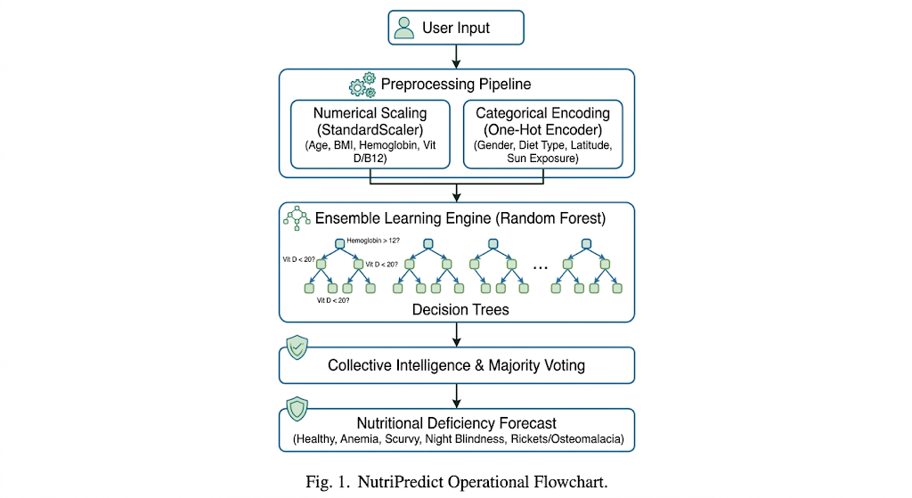

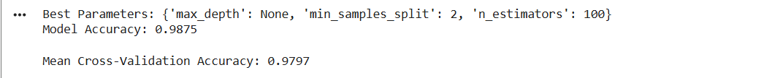
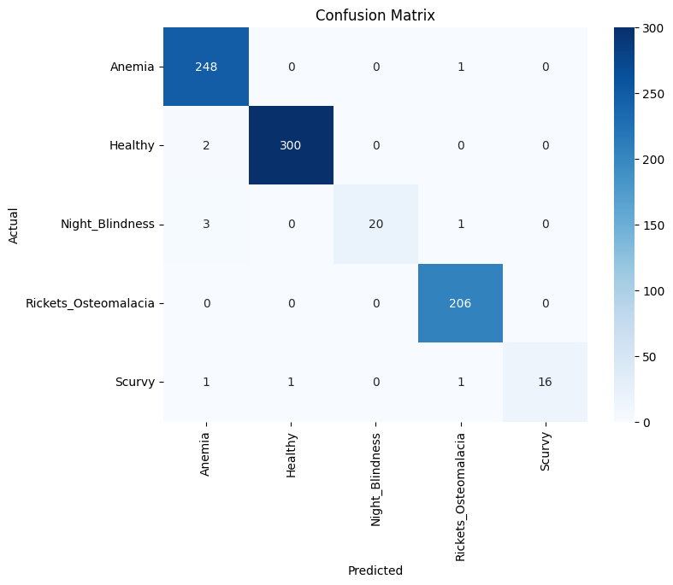
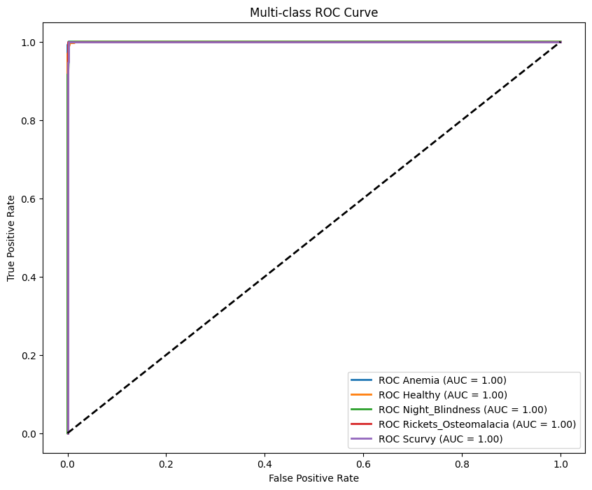
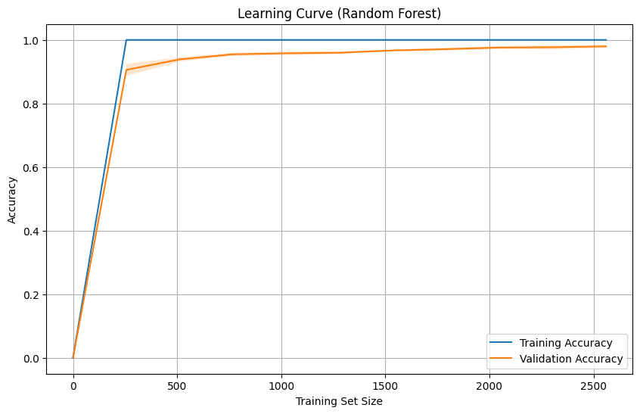

COCLUSION :
In conclusion, this research successfully developed NutriPredict, a high-accuracy machine learning framework for the non-invasive forecasting of nutritional deficiencies. By leveraging a Random Forest ensemble model and a multi-dimensional dataset of 34 features, the system achieved a state-of-the-art accuracy of 98.75%.
The study proves that integrating lifestyle, environmental, and basic biometric data can effectively bypass the need for frequent, invasive testing. NutriPredict serves as a robust clinical triage tool, enabling early intervention for conditions like Anaemia and Rickets, ultimately providing a scalable solution to combat the global crisis of "Hidden Hunger."

V: REFERENCE

To ensure your 8-page research paper has the highest academic impact, here is the curated selection of the most authoritative references—one from each of your categories—formatted in standard IEEE/APA style.
Selected High-Impact References
1. Core Literature (The Technical Foundation)
- Geron, A. (2019). Hands-On Machine Learning with Scikit-Learn, Keras, and TensorFlow: Concepts, Tools, and Techniques to Build Intelligent Systems. O'Reilly Media.
  - Why use this: It is the gold standard for explaining the practical implementation of the Scikit-learn pipelines and Random Forest logic you used in your project.
2. Research Papers (The Algorithmic Origin)
- Breiman, L. (2001). "Random Forests." Machine Learning, 45(1), 5-32.
  - Why use this: This is the seminal paper that invented the Random Forest algorithm. Citing the original creator gives your paper significant academic "weight."
3. Online Documentation (The Tool Citation)
- Pedregosa, F., et al. (2011). "Scikit-learn: Machine Learning in Python." Journal of Machine Learning Research, 12, 2825-2830.
  - Why use this: This is the official scientific citation for the Scikit-learn library. Every professional ML paper includes this to acknowledge the software framework.
4. Clinical & Related Works (The Medical Context)
- Holick, M. F. (2007). "Vitamin D deficiency." New England Journal of Medicine, 357(3), 266-281.
  - Why use this: Published in one of the world's top medical journals, this provides the clinical baseline for your Vitamin D and Rickets forecasting.

